**ASSIGNMENT 1**

HTML form

|  |  |
| --- | --- |
| Assignment Date | 28 October 2022 |
| Student Name | Nishanthini V |
| Student Roll Number | 820419104044 |
| Maximum Marks | 2Marks |

Question-1:

Create registration page in HTML with username and phone number and by using POST method display it in next Html page.

Program:

<html>

<head>

<title>

Registration Page

</head>

</title>

<body>

<form action="/index" method="POST">

Username:

<input type="text" name="username" size="15"/> <br>

<br>

Phone :

<input type="text" name="number"><br>

<br>

Email:

<input type="email" id="email" name="email"/> <br>

<br> <br>

</body>

</html>

Output:

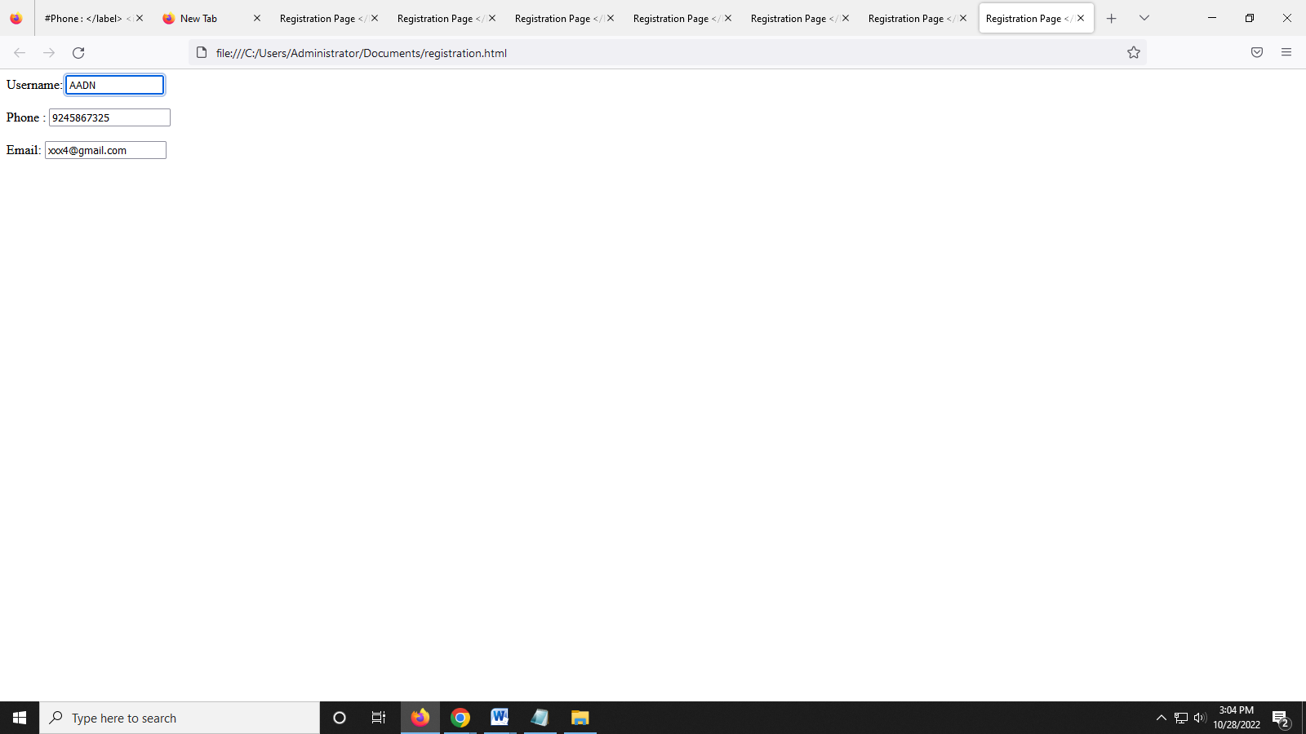

Question-2

Develop a flask program which should contain atleast 5 packages used from pypi.org.

Program

# Importing flask module in the project is mandatory

# An object of Flask class is our WSGI application.

from flask import Flask

# Flask constructor takes the name of

# current module (__name__) as argument.

app = Flask(__name__)

# The route() function of the Flask class is a decorator,

# which tells the application which URL should call

# the associated function.

@app.route('/')

# ‘/’ URL is bound with hello_world() function.

def hello_world():

    return 'Hello World'

# main driver function

if __name__ == '__main__':

    # run() method of Flask class runs the application

    # on the local development server.

    app.run()